Visitor’s Management System

Software Requirements Specification (SRS) for Visitor Management System

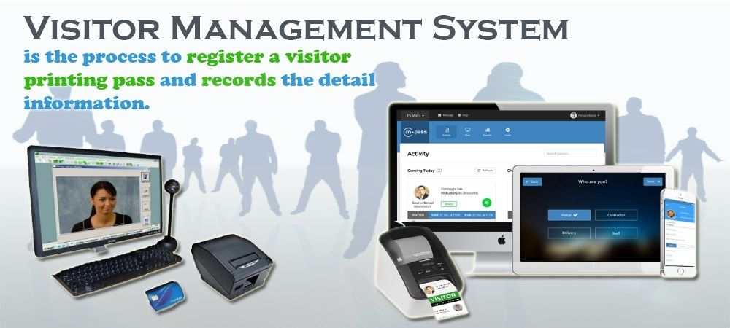

Authors:

1]Omkar Aher(SIA02)

2]Mahadev Bhosale(SIA14)

3]Chinmay Boddawar(SIA16)

4]Mohak Borole(SIA19)

DOCUMENT VERSION : 1

TABLE OF CONTENT:

1. INTRODUCTION:

1.1 GENERAL DISCRIPTON.

1.2. OBJECTIVE OF THE DOCUMENT:

1.3 SCOPE OF THE PROJECT.

2. FUNCITIONAL REQUIREMENTS:

2.1. Visitor Registration

2.2. Check-In

2.3. Visitor Logs

3. Non-Functional Requirements :

3.1 Usability

3.2. Performance

3.3. Security

3.4. Compatibility

4. Constraints :

4.1. Hardware Requirements

5 .Software Requirements :

6. Use Case Diagram:

7 .Testing Plan :

8 . E – R Model :

9. Project Plan :

10 .References :

1. Introduction:

The Visitor Management System is a software system designed to manage visitors in a company or organization. The system will facilitate the check-in and check-out process, capture visitor information and Face, and ensure the security of the premises.

#OBJECTIVES OF PROJECT:

1. Maintain the visitor’s entry easily and Facilitate visitor the ease to register.
2. Keep workspace Safe .
3. Securing Clients Building.

#Scope of Project:

->the project is custom software to manage visitor’s in an institute.

1. Working :

->When person comes to meet the Admin the webcam will Scan their faces.

->After Scanning the System will check the person’s data is available in database or not.

->Searching will be done by their given their face.

->If the person’s data is available in database the System will fetch his/her ‘

Name, Contact Number . `

->The Information about the visitor is displayed on admin’s System.

->The Admin will then decide whether to Allow the person to visit,

Put him/her on waiting list.

->If the admin don’t respond within 1 min the System will send a Automated

Whatsapp message to visitor mentioning that “Sorry!!Admin is not Available right now , please try after some time.”

1. Functional Requirements :

The system shall have the following features:

2.1. Visitor Registration

-> The system shall allow the user to register new visitors.

-> The system shall require the visitor’s ID, name, phone number.

-> The system shall capture a photo of the visitor for identification purposes.

2.2. Check-In

-> The system shall allow the user to check-in visitors.

-> The system shall verify the visitor’s identity by matching the photo with the registered information.

2.3. Visitor Logs

-> The system shall maintain a log of all visitor activity.

-> The system shall record the visitor’s name, check-in.

-> The system shall allow the user to search and filter the visitor log by date, time, visitor name.

-> Notifications

-> The system shall send notifications to the Admin when their visitor checks in.

4. Non-Functional Requirements :

3.1 Usability

-> The system shall have a user-friendly interface.

-> The system shall be easy to navigate.

-> The system shall provide clear instructions to the user.

3.2. Performance

-> The system shall be able to handle a high volume of visitors.

-> The system shall respond to user input within 2 seconds.

3.3. Security

-> The system shall require a login for access.

-> The system shall use secure encryption to protect visitor data.

-> The system shall restrict access to visitor data to authorized users.

3.4. Compatibility

-> The system shall be compatible with Windows, macOS, and Linux operating systems.

-> The system shall be compatible with Windows 7/8/10 and Above.

5. Constraints :

4.1. Hardware Requirements

-> The system shall require a computer with a minimum of 4 GB RAM.

-> The system shall require a webcam for capturing visitor Face.

6 .Software Requirements :

->The Visitors Management System shall allow authorized personnel to register and manage visitors.

->The system shall maintain a database of all registered visitors.

->The system shall allow authorized personnel to view the visitor database and generate reports.

->The system shall Recognize the Student or Faculty member as their data and face is already present in System.

->The system shall send notifications to admin when their visitors arrive.

->The system shall allow Admin to pre-register visitors.

->The system shall allow visitors to check-in

->The system shall restrict access to sensitive areas to authorized personnel only.

->The system shall maintain a log of all system activities.

7. Use Case Diagram:

The use case diagram for the Visitors Management System is shown below:

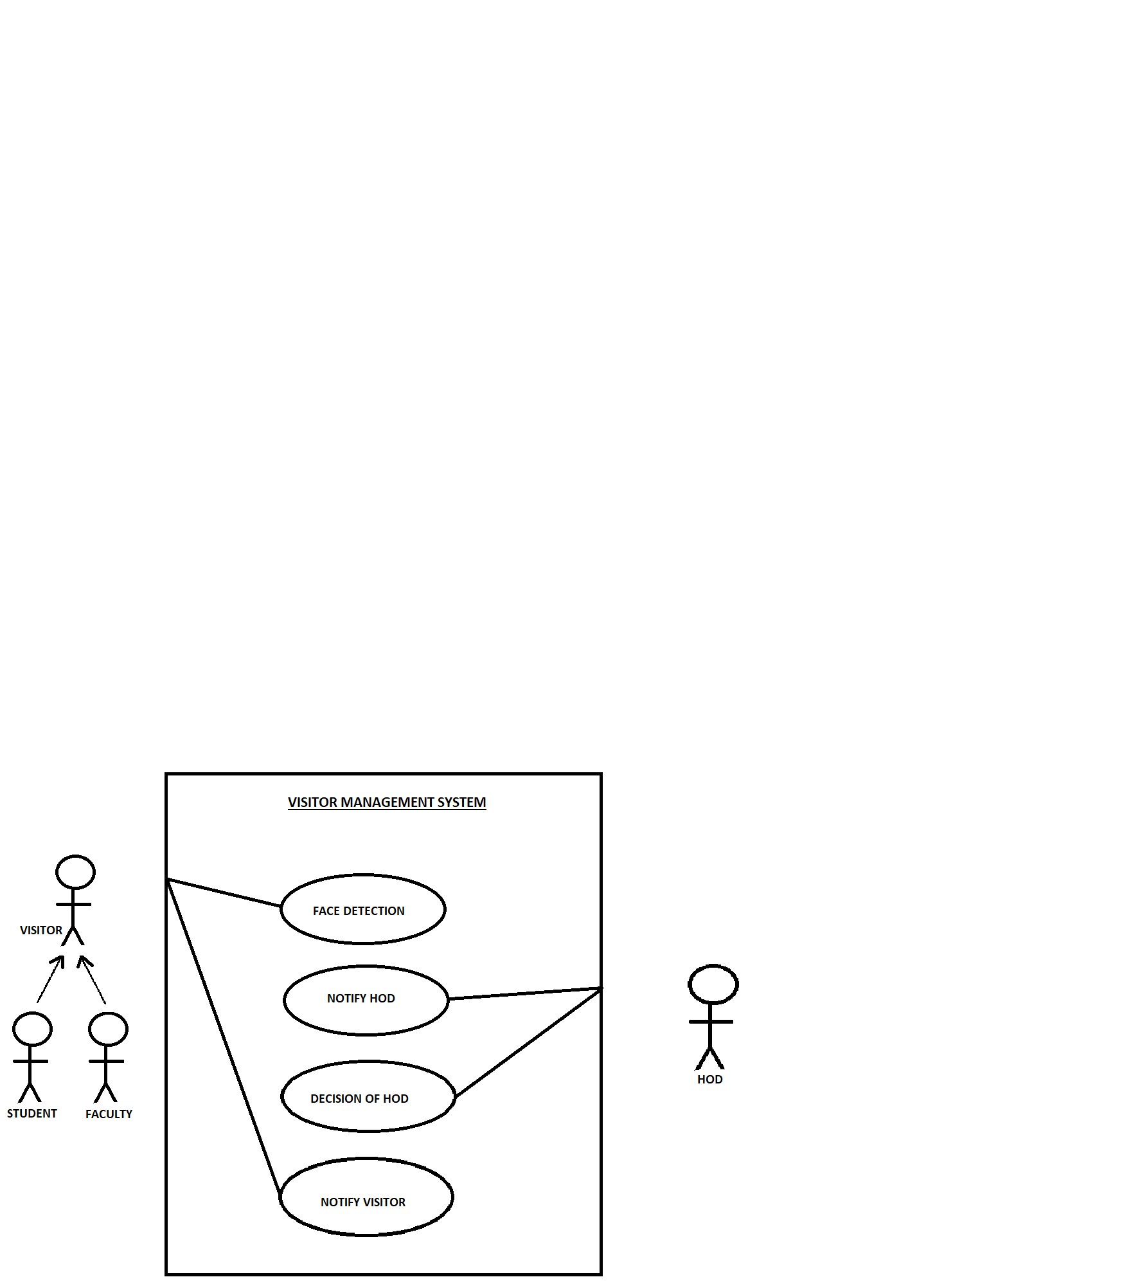

8 .Testing Plan :

The testing plan for the Visitors Management System shall include the following steps:

->Unit Testing: Each module shall be tested individually to ensure its functionality.

->Integration Testing: Modules shall be tested in combination to ensure they work together as expected.

->System Testing: The entire system shall be tested to ensure it meets the system requirements.

->Face Recognition Test: The system shall be tested by users to ensure it Recognize the Authorized persons.

9. E – R Model :

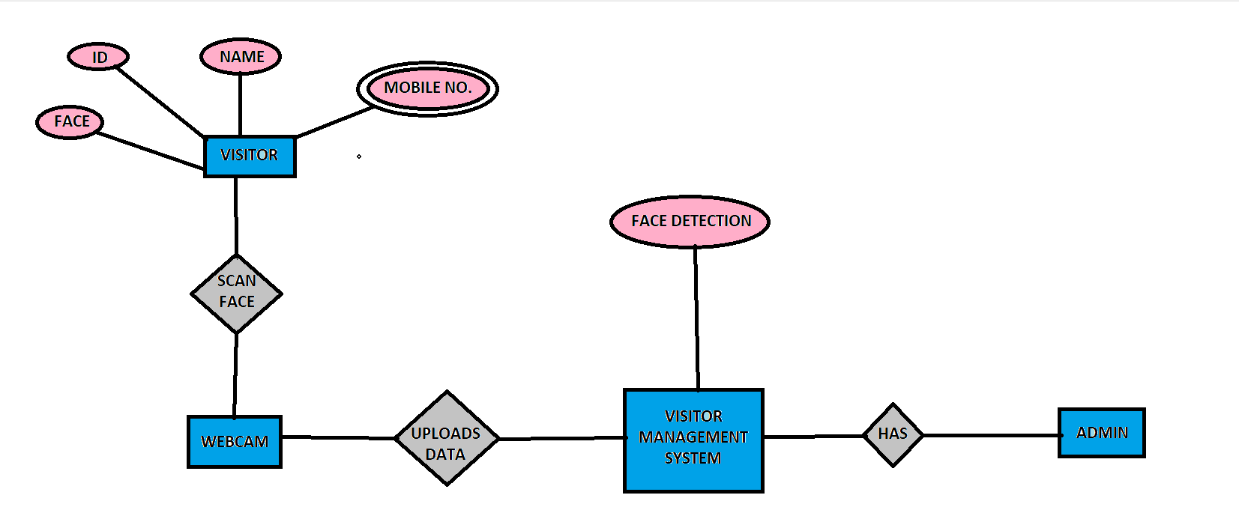

10.Data Flow Diagram:

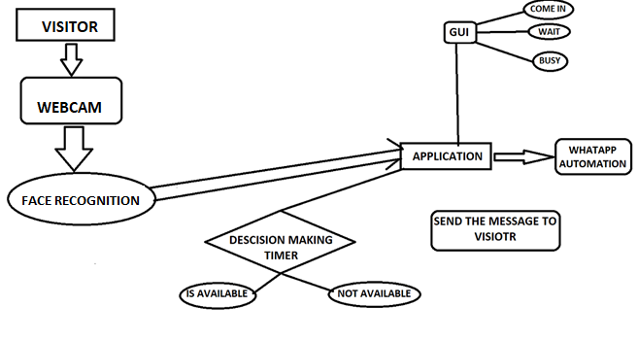

10. Project Plan :

The project plan for the Visitors Management System shall include the following steps:

Requirements Gathering: Gather system requirements from Internet.

Technology Requirement: Face Recognition and databases.

Design: Develop a design for the system based on the requirements.

Implementation: implement the system.

Testing: Test the system to ensure it meets the system requirements.

Maintenance: Provide ongoing maintenance and support for the system.

11 .References :

"Visitor Management System." TechTarget, 2021,

<https://www.swipedon.com/blog/what-is-visitor-management>